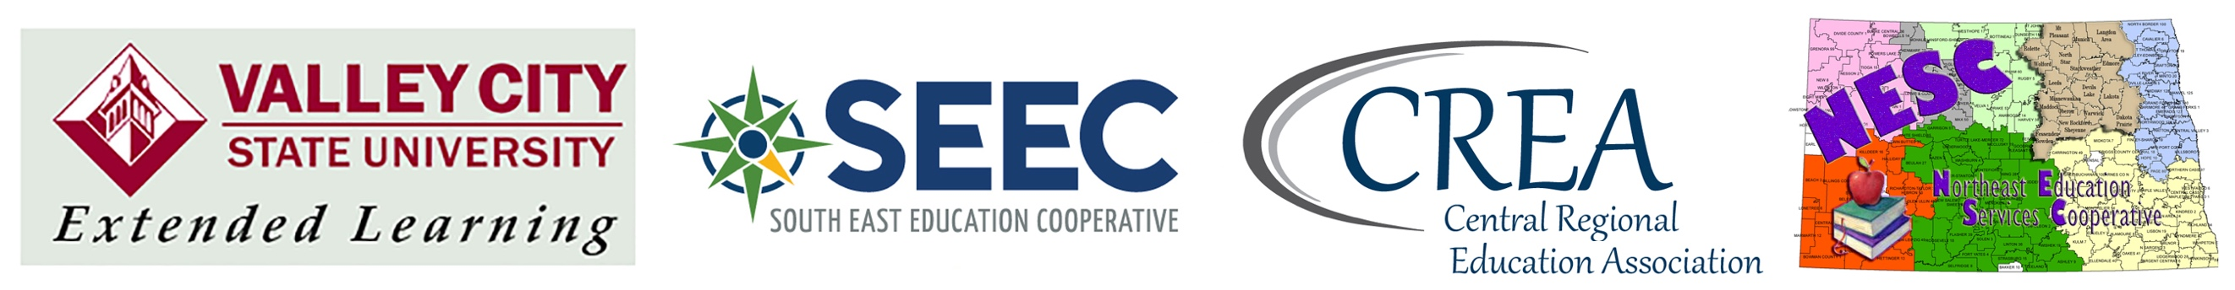

SEEC/CREA/NESC/GNWEC
Workshop Verification Hours

You will need to complete one table on this verification form for every professional development activity you attend if you are working toward a total of 15 workshop hours to receive one graduate credit. Additional pages can be used if needed.

When you have attended a total of 15 professional development hours and have verification forms completed for those hours, register for the credit from VCSU www.vcsu.edu/extend, click on Registration and Course Availability button. Select the EDUC 2000 ST: Professional Development (SEEC/CREA/NESC) course/s.

Return all verification forms to:  Dave Bass  VCSU School of Education  101 College Street  Valley City, ND 58072 | I have registered for the EDUC 2000 Course  I have paid for the class  My administrator has signed the form

Please make copies of your verification forms for your own documentation.

Name: |  |  | email:
school: |  |  | phone:
District: |  |  | REA:
Administrative Supervisor Signature:

P.D. Activity Title:
Total Hours: |  | Date:
How will this PD Activity help you improve your teaching?
How will this PD Activity promote increases in student achievement?

P.D. Activity Title:
Total Hours: |  | Date:
How will this PD Activity help you improve your teaching?
How will this PD Activity promote increases in student achievement?

P.D. Activity Title:
Total Hours: |  | Date:
How will this PD Activity help you improve your teaching?
How will this PD Activity promote increases in student achievement?

P.D. Activity Title:
Total Hours: |  | Date:
How will this PD Activity help you improve your teaching?
How will this PD Activity promote increases in student achievement?

P.D. Activity Title:
Total Hours: |  | Date:
How will this PD Activity help you improve your teaching?
How will this PD Activity promote increases in student achievement?

P.D. Activity Title:
Total Hours: |  | Date:
How will this PD Activity help you improve your teaching?
How will this PD Activity promote increases in student achievement?

